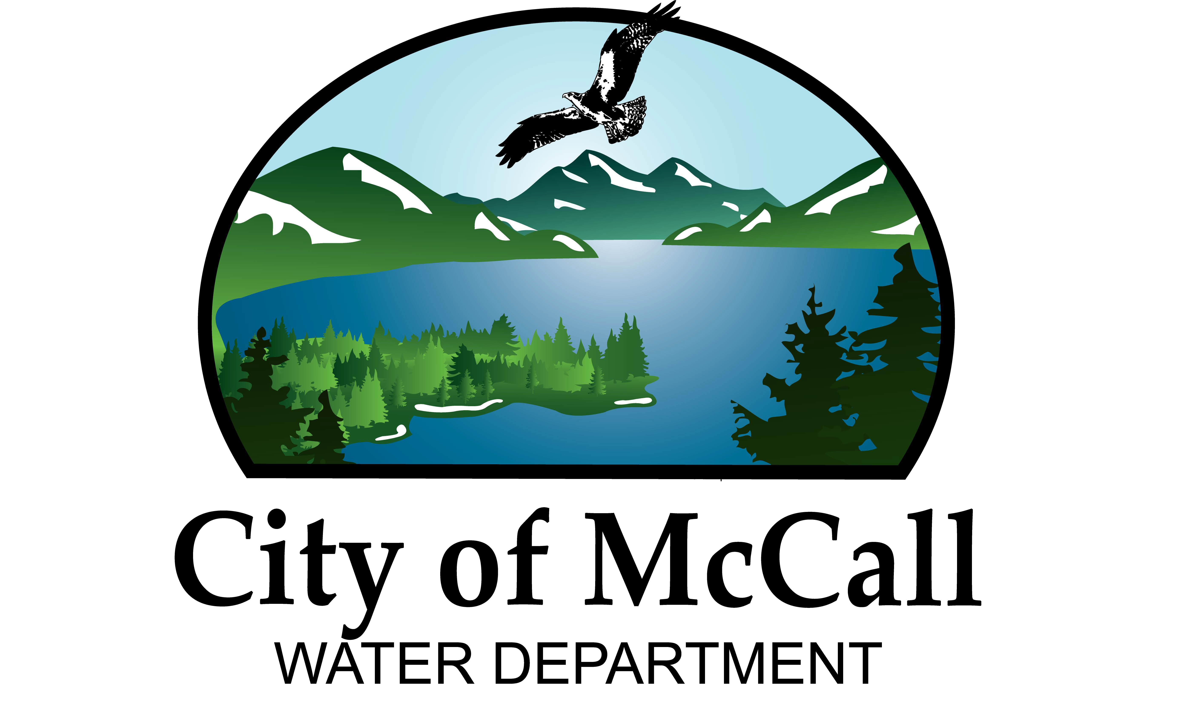

Water Production Manager
Pay Grade: PW7
FLSA Designation: Non-Exempt
Hybrid Remote Work: Not Eligible
General Statement of Duties:
Under direction from the Water Systems Manager, plans, organizes and directs water quality activities and the operation of City’s Water Treatment Facility (WTF), laboratory, pumping facilities and related distribution and storage facilities; strategizes, monitors and ensures Cities compliance with water quality standards and regulations; plans, schedules, supervises and reviews the work of professional and technical staff engaged in technical operations support; prepares the WTF program’s annual budget, estimating staffing, materials and equipment needs and monitors program expenditures after budget adoption; prepares a variety of technical and administrative reports related to the operation of water production facilities; and performs other related work as required.

Summary:
The Water Production Manager is a single-position mid-manager classification. Under limited direction within a framework of overall goals and objectives, this position oversees water quality, operations support activities and the City’s plant operations and pumping activities. Assignments are given in general terms and subject to review upon completion. There is significant latitude for discretion and independent judgment to achieve overall goals and objectives of areas of responsibility. This classification is distinguished from other managers within the city by the specific responsibility for ensuring water quality compliance during operations and maintenance activities as well as ensuring water production activities are carried out in such a way to meet customer needs. This classification is distinguished from the Operations Superintendent in that the latter has an overall administrative responsibility for all operations and maintenance activities of the city water system and provides direction to this classification. The work requires this employee to be on-call 24/7 for emergencies. The employee must perform all work duties and activities in accordance with City policies, procedures, and safety policies.
Supervision Received: Water Systems Manager

Jobsite Supervision Exercised: Activities completed within the WTF and Associated pumping, storage and distribution facilities.

Essential Job Functions:
- Oversee day-to-day operations, maintenance and repair of treatment plant, water quality laboratory, storage tanks, and pumping stations.
- Direct, schedule, and inspect general plant operations, maintenance, and plant shutdowns, direct plant operations in emergency situations.
- Develop and recommend changes to water treatment plant processes and approach, and minor equipment changes as necessary, in collaboration with the Operations Superintendent and Water Systems Manager.
- Develop, manage, and report on Key Performance Indicators to measure work performance, operations, and maintenance requirements.
- Assume accountability for the protection of the environment and public through compliance with water quality requirements, permit parameters, other federal, state, and local regulations, and for accurate field laboratory data, and an effectively managed asset management program.
- Identify, recommend, and manage major improvements in plant, equipment, and facilities, including design or construction projects that involve outside consultant and contractors.
- Prepare technical specifications, review, and approve chemical purchases, repair contracts, new equipment, and materials, monitor contract performance.
- Direct the evaluation of new chemicals and treatment processes and procedures to maintain consistent water quality in the distribution system.
- Direct the analysis of all plant operations phases and methods to develop more efficient, cost effective, and technologically advanced methods of water treatment.
- Partner with leadership on matters of policy and short and long-term planning.
- Develop departmental budget including personnel, equipment, and capital planning.
- Perform all operational duties of the treatment plant and pumping stations including but not limited to regulating the addition of chemicals, operating pumps, checking gauges and flowmeters.
- Conducts laboratory tests to ensure water quality guidelines are being met and exceeded.
- Ability to understand and use SCADA (Supervisory Control and Data Acquisition) software.
- Fields public inquiries regarding water quality, taste, and odor concerns.
- Performs repair and maintenance at all water facilities, including all assets associated with those facilities.
- Performs other related tasks as assigned or required.
- The nature of this position requires the ability to respond to emergencies in a timely fashion. The position residency shall be such that when the employee is notified of an emergency, the safe and prudent driving time to the water treatment plant shall be within 30 minutes of notification.

Peripheral Job Duties:
- On-call rotation for treatment and distribution system after regular work hours to respond to emergency situations.
- Performs other related duties as required.
Note: The functions and duties listed are intended only as illustrations of the various types of work that may be performed. The omission of specific statements of duties does not exclude them from the position if the work is similar, related or a logical assignment to the position. The job description does not constitute an employment agreement between the employer and employee and is subject to change by the employer as the needs of the employer and requirements of the job change.

Knowledge, Skills, and Abilities
Knowledge of:
- Extensive knowledge of surface water treatment, process design and operations, water treatment and process engineering, laboratory sampling and analysis, process and distribution system hydraulic principles, pneumatics, mechanics, electronics, construction, and maintenance related to potable water facilities operations.
- Extensive knowledge of unit process design and operations, process chemistry, and chemical reactions related to potable water treatment.
- Excellent leadership skills, with the ability to lead, motivate and empower employees.
- Strong analytical, planning and organization skills.
- Federal, state, county, and other applicable statutes, law, regulations, and procedures to meet public health and environmental standards for water distribution and treatment, as well as.
- Computerized and automated system monitoring and control equipment (i.e., SCADA), procedures, and operation.
- The proper methods of repairing, lubricating, and maintaining mechanical equipment.
- The principles, practices, equipment, and methods used in water distribution, treatment, and pumping operations.
- Methods, equipment, materials, procedures, tools, and standard practices for water sampling, also chemical and bacteriological testing.
- Equipment and tool operation and maintenance practices.
- Mechanical apparatus, electrical, pump, and pipe fitting methods and techniques.
- Methods, equipment, materials, tools, and standard practices for the operation and maintenance of water treatment facilities.
- The occupational hazards connected with water plants, water distribution, and related activities are also necessary safety precautions.
- Identify most parts used by name or as called out in our inventory and have the knowledge of its use and application.
- Federal OSHA, AWWA, EPA & IDEQ regulations, practices, policies, & procedures.

Ability to:
- Plan, assign, and coordinate a comprehensive water quality control and monitoring program.
- Plan, assign, and coordinate water production and distribution system operations programs.
- Interpret and explain policies and procedures to persons with varying educational backgrounds.
- Analyze complex technical problems, evaluate alternatives, and reach sound conclusions.
- Maintain, repair, and adjust water pumps, chemical feed machines, and other water plant and distribution equipment.
- Read and interpret system technical and operational manuals and guidelines.
- Analyze and interpret computer, statistical, and laboratory data, including using the information to prepare reports and recommendations.
- Take accurate readings, keep routine records, and make arithmetic computations.
- Operate specialized equipment appropriate to assigned inspection, maintenance, and repair duties.
- Operate manual and automated valve, pump, and control systems.
- Operate standard office equipment, including a personal computer and applications appropriate to assigned duties.
- Use and understand the city’s asset management program.
- Use and take care of hand and bench tools.
- Follow verbal and written instructions.
- Exercise independent judgment as appropriate.
- perform essential duties of the job without causing harm to self or others.
- Establish and maintain effective working relationships with employees and administrative superiors.
- Work a rotating on call night and weekend shift and be on call 24/7 for emergencies.
Acceptable Experience and Training
- High school diploma or GED required and possession of an bachelor’s degree from an accredited college or university with major course work in engineering, biology, chemistry, or a related field or a certificate from a technical program specializing in Water; and
- Four (4) years of progressively responsible experience in the operation of water treatment plants and distribution systems or in water quality planning and equivalent environmental engineering, including three (3) years of lead experience directing the work of others in the field. Supervisory experience strongly desired.
- Minimum of six (6) years hands on surface water treatment plant operation preferred.
- Minimum of three (3) years water distribution field experience.
OR
- Any equivalent combination of experience and training which provides the knowledge and abilities necessary to perform the work.
Necessary Special Requirement
- Have a valid driver’s license.
- Obtain a Class B CDL and air-break endorsement within 6 months of hire.
- Have a Class III IBOL Water Treatment Operator License or the ability to obtain one within 6 months.
- Have an IBOL Class II Operator License for Water Distribution or be able to obtain within 12 months of hire.
- Test for available upgrades for IBOL Water Distribution Operator and/or Water Treatment Operator licenses within one year of qualifying.
- Must be insurable under the City’s motor vehicle insurance policy.
- Must be able to perform daily duties without supervision.
- Must be able to respond within 30 minutes when on-call.

Essential Physical Abilities
- Sufficient clarity of speech and hearing, with or without reasonable accommodation, which permits the employee to discern verbal instructions, communicate with other employees and the public, and discern warning or emergency alarms, including vehicle backup warnings.
- Sufficient visual acuity, with or without reasonable accommodation, permits the employee to comprehend written work instructions, technical manuals, and related diagrams, read meters and gauges, and discern color-coded equipment indicators.
- Sufficient manual dexterity, with or without reasonable accommodation, which permits the employee to operate a motor vehicle, operate a personal computer, operate manual valve, and pump controls, operate a variety of power and hand tools, and to adjust equipment.
- Sufficient body strength, mobility, agility, flexibility, and stamina to lift and move 50 pounds regularly and 100 pounds occasionally, and balance to perform operation and maintenance tasks which require bending, stooping, kneeling, reaching, twisting, climbing, and working on ladders, working in enclosed spaces, and working in a treatment plant environment.
- Maintain a physical size that allows the person to enter a confined space with a circumference as small of 24 inches, unassisted.

Work Environment:
The work environment characteristics described here are representative of those an employee encounters while performing the essential functions of this job. Reasonable accommodations may be made to enable individuals with disabilities to perform the essential functions. While performing the duties of this job, the employee frequently works near moving mechanical parts and is frequently exposed to fumes or airborne particles. The employee occasionally works in outside weather conditions, in high, precarious places and in confined spaces. The employee is occasionally exposed to wet and/or humid conditions, toxic or caustic chemicals, and the risk of electrical shock. The noise level in the work environment is moderate to loud.

The City of McCall does not discriminate based on race, color, national origin, sex, genetics, religion, age or disability in employment or the provision of services and complies with the provisions of the Idaho Human Rights Act.

The City of McCall is an Equal Opportunity Employer

